**DAILY ONLINE ACTIVITIES SUMMARY**

|  |  |  |  |  |  |  |  |  |
| --- | --- | --- | --- | --- | --- | --- | --- | --- |
| **Date:** | **20/05/2020** | | | | | **Name:** | **Lavanya D M** | |
| **Sem & Sec** | **4th & ‘A’** | | | | | **USN:** | **4AL18CS041** | |
| **Online Test Summary** | | | | | | | | |
| **Subject** | | **OOC** | | | | | | |
| **Max. Marks** | | **30** | | **Score** | | | **16** | |
| **Certification Course Summary** | | | | | | | | |
| **Course** | **HTML AND CSS** | | | | | | | |
| **Certificate Provider** | | | **BITDEGREE** | | **Duration** | | | **2week** |
| **Coding Challenges** | | | | | | | | |
| **Problem Statement:** Given an array a[] of size n which contains elements from 0 to n-1, write a program printDuplicates which prints the duplicate elements of the given array. If no duplicate element is found print -1. Input: The first line of input must contains an integer n which denotes number of elements of Array. Second line contains n space separated integers denoting elements of array a[].  Output: Print the duplicate elements from the given array. | | | | | | | | |
| **Status:complied** | | | | | | | | |
| **Uploaded the report in Github** | | | | | **yes** | | | |
| **If yes Repository name** | | | | | <https://github.com/lavanyamurthi/lockdown-coding/blob/master/20may%20areaofiso> | | | |
| **Uploaded the report in slack** | | | | | **yes** | | | |

Online Test Details: (Attach the snapshot and briefly write the report for the same) 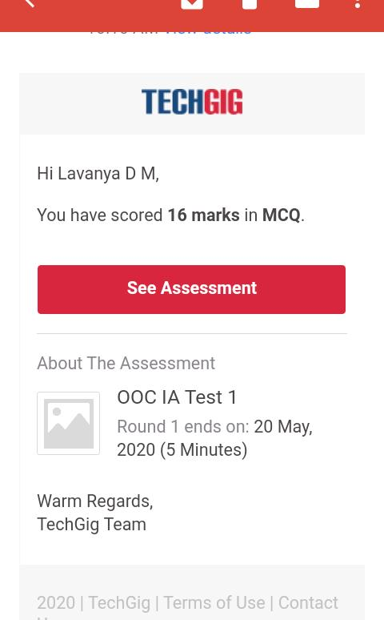

Certification Course Details: (Attach the snapshot and briefly write the report for the same)

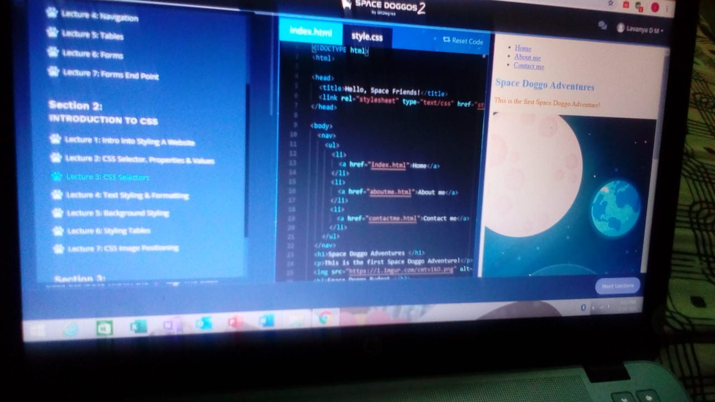

Coding Challenges Details: (Attach the snapshot and briefly write the report for the same)

